Janis Joplin Musical Coming to Broadway

**“I'm one of those regular weird people”**

By [PATRICK HEALY](http://artsbeat.blogs.nytimes.com/author/patrick-healy/)

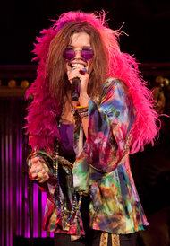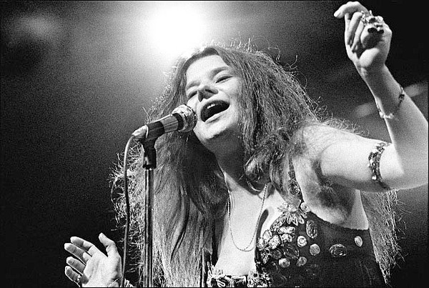

Janis Joplin

Mary Bridget Davies in “Janis Joplin musical”.

“A Night with Janis Joplin,” a concert-as-theater featuring a buzz-generating performance by Mary Bridget Davies as Joplin, will open on Broadway this fall after touring the country over the last two years. The producers Todd Gershwin (a great-nephew of George and Ira Gershwin) and Daniel Chilewich, in association with Joplin’s estate, announced the Broadway plans on Wednesday, with performances beginning Sept. 20 at the Lyceum Theater and an opening night of Oct. 10.

Ms. Davies, a blues singer from Cleveland who will be making her Broadway debut, has earned strong reviews during the show’s runs in Portland, Washington, D.C., Pasadena, and elsewhere for her vocal performances of Joplin hits like “Piece of My Heart,” “Ball and Chain,” and “Me and Bobby McGee.” The show, which largely takes the form of an imagined Joplin concert, is written and directed by Randy Johnson. Additional casting will be announced later; according to reviews during the tour, the show also features an actress playing several famous singers who were inspirations to Joplin, like Bessie Smith and Aretha Franklin.

Asked for the total cost of the Broadway production, a spokesman for the show said, “The producers have declined to comment on the capitalization but we can say it has been budgeted for a house that is traditionally a home for plays.” That amount is typically in the mid-seven figures.